CPE 4800 - Senior Design Proposal, Fall 2025

Product Proposal Document

FlexType EMG Keyboard
Half-Byte Solutions

Rev. - Final
Date: December 14, 2025
Electrical and Computer Engineering
Kennesaw State University
Faculty: Dr. Jeffrey L Yiin
Revision History
Name | Date | Reason For Changes | Version
Julia Johnson | 11-3-2025 | Initial Release | Rev. – Draft
Julia Johnson | 11-4-2025 | Added Product Specifications | Rev. – Draft A
Kejon Ivery | 11-4-2025 | Added Product Requirements | Rev. – Draft B
Jalen Tottress | 11-4-2025 | Added System Architecture | Rev. – Draft C
Giancarlos Hernandez | 11-4-2025 | Added Introduction | Rev. – Draft D
Jalen Tottress | 12-11-2025 | Updated Bill of Materials pricing | Rev. – Draft E
Jalen Tottress | 12-11-2025 | Updated Flow of Events for each use case. Updated System Architecture Diagrams | Rev. – Draft F
Julia Johnson | 12-14-2025 | Added Project Plannng and Updated Product Specifications | Rev. - Draft G
Giancarlos Hernandez | 12-14-2025 | Updated Into and Added Constrains | Rev. – Draft H
Kejon Ivery | 12-14-2025 | Updated Product Requirements and Proof of Concept (Feasibility) | Rev. - Draft I
Julia Johnson | 12-14-2025 | Edited Figure Labels | Rev. - Final

Table of Contents
I. Introduction 5
i. High-Level Product Description 5
ii. Key Product Feature Sets 5
a. Motion Detection Sensor System 5
b. AI Models 5
c. Smartphone App 6
iii. Value Proposition to the Customers 6
iv. Target Market Analysis 6
v. Visual representation of the product 6
II. Product Specifications 7
III. System Architecture 9
Use Case 1: Sending a Text Message 12
Use Case 2: Starting up the EMG Wristband 13
Use Case 3: Gesture Error Correction 14
Bill of Materials (BOM) - Key Components & Estimated Costs 16
IV. Product Requirements 17
FlexType Model Sub-System 17
FlexType Wristband Sub-System 17
User Device Sub-System 18
V. Relevant Engineering Standards 19
VI. Realistic Constraints and Design Impact 20
VII. Proof-of-Concept (Feasibility) Projects 21
Main Issues 21
VIII. Project Planning 25
Phase 1 25
Phase 2 26
Phase 3 28
Gantt Chart 29
Bibliography 30

List of Figures
Figure 1. Visual of the Product 7
Figure 2. Top Level Block Diagram 9
Figure 3. Software System 10
Figure 4. Wristband Subsystem 10
Figure 5. User Device Subsystem 11
Figure 6. FlexType Model Subsystem 11
Figure 7. Use Case 1 Swim Lane Diagram 13
Figure 8. Use Case 2 Swim Lane Diagram 14
Figure 9. Use Case 3 Swim Lane Diagram 15
Figure 10. EMG Collecting Data 22
Figure 11. Word Model Predicting "Hello" 23
Figure 12. Word Model "Hello" Results 23
Figure 13. Predicting “Cat" with Left Context "The" 24
Figure 14. Context Predicting Results 24
Figure 15. Gantt Chart 29

List of Tables
Table 1. Product Requirements 7
Table 2. Bill of Materials 16
Table 3. Relevenat Engineering Standards 19
Table 4. Realistic Constraints 20
Table 5. Phase 1 Plan 25
Table 6. Hardware Development Plan 26
Table 7. Software Development Plan 27

Introduction

High-Level Product Description
The FlexType EMG Keyboard is a wearable wristband device that can detect the EMG signal from the muscles in your arms and convert them into text inputs. This device is designed for individuals with neurological disorders that limit hand or arm mobility and provides an accessible, versatile, and private alternative to traditional keyboards. By using an AI model trained to recognize different hand gestures, each corresponding to a different set of letters, our product can use a word prediction AI model to allow the user to type their desired word.

Key Product Feature Sets
In order to ensure accessible and private communication for individuals with limited hand and arm mobility, the device incorporates the following feature sets:

Motion Detection Sensor System
The motion detection system allows users to communicate using natural hand gestures instead of relying on traditional input devices. The device will consist of two types of sensors in order to detect muscle activity and arm movement: an Electromyography (EMG) sensor and an Inertial Measurement Unit (IMU) sensor. The EMG sensor will be used to detect the EMG signals from the muscle in a user’s arm when performing a gesture. The IMU sensor will be measuring the position and orientation of the user’s arm and hand. By using these two sensors, the device can accurately capture the user’s intended gestures even with limited mobility. This gives users a more comfortable and accessible way to communicate.

AI Models
The product will rely on two AI models in order to successfully interpret the word a user wants to type. Both of these models will run locally on the Raspberry Pi. Firstly, the Gesture Recognition AI Model will take in the output of the EMG and IMU sensors and output a set of letters based on the gesture it recognized. Then, the Word Prediction AI Model receives the outputs from the Gesture Recognition AI Model, the different sets of letters, and predicts the word the user is trying to type.

Smartphone App
The product will include a corresponding smartphone application in order to perform the task of typing for the user. This application will be simulated on the Raspberry pi which will connect physically to the wristband in order to receive the data from the wristband. It will also be running the AI models locally and will display the words typed by the user.

Value Proposition to the Customers
The value proposition for our customers is that the FlexType EMG keyboard will provide an accessible, versatile, and private means of text-based communication. It will be very accessible to users by being lightweight as well as requiring very subtle movements which a traditional keyboard cannot provide. It will also be portable and able to be used in various different environments, making it very versatile. Lastly, it provides privacy by taking in silent inputs, unlike Voice-to-Text, which allows for discrete messaging.

Target Market Analysis
Our FlexType sits between two markets of vastly different sizes: the gesture recognition market which is valued at $25.4 billion and the wearable EMG market which is valued in the low hundreds of millions USD. This indicates that our product could potentially have a very good revenue upside when it comes to long-term growth due to the sizes of the two markets. However, in the short term, the product will be a part of a very niche market due to its very specific use case. In terms of potential buyers, the amount of neurologically disabled individuals that would benefit from our product is around 20-30 million in the US. However, our product is not limited to those individuals and can also benefit elderly individuals, visually impaired individuals and individuals with missing fingers which have a population of around 20 million, 7 million, and 500 thousand respectively. This means that the total market size for our product is around 50 to 60 million individuals.
Our main competitor producing EMG gesture recognition wristbands is Meta which uses them in order to control devices/UI for VR/AR applications. While they have an advantage over our product by having an established market and a released product, their solution would not be able to perform the functions that our product requires. Their reliance on precise finger tapping makes them less suitable for individuals with limited motor control, which means their product is not accessible for our market population.

Visual representation of the product
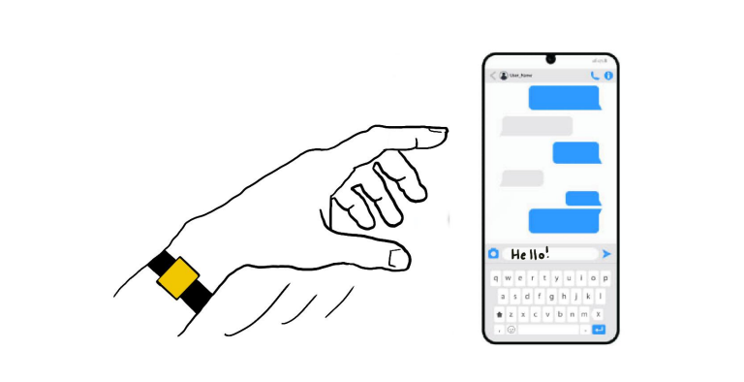
Figure 1. Visual of the Product
This image demonstrates a person performing a gesture while wearing the wristband and text appearing on the device’s screen as a response to it.

Product Specifications
Table 1. Product Requirements
Requirement ID | Description | Category | Priority
FNC-1 | The wearable device shall operate in a low-power sleep mode when not in active use. | Functional | Nice to Have
FNC-2 | The EMG wristband shall convert the analog EMG signal into a digital signal. | Functional | Must Have
FNC-3 | The EMG and IMU sensors will share data with the user’s device. | Functional | Must Have
FNC-4 | The gesture classification and word prediction models may run locally on the user’s device. | Functional | Nice to Have
FNC-5 | The final typed output may be understandable with text-to-speech. | Functional | Nice to Have
PER-1 | The gesture classification algorithm shall have an accuracy of at least 90%. | Performance | Must Have
PER-2 | The word prediction algorithm shall have an accuracy of at least 90%. | Performance | Must Have
PER-3 | The EMG wristband shall “wake-up” within 5 seconds of the user performing the activation gesture. | Performance | Nice to Have
IFC-1 | The wearable device shall read gestures when a user’s arm is in predetermined positions. | Interface | Must Have
IFC-2 | The gesture model shall wait for the gesture that indicates a space or period to begin sending the saved data to the word prediction model. | Interface | Must Have
IFC-3 | The model shall include a “backspace” gesture for incorrectly typed words. | Interface | Must Have
IFC-4 | The model shall include a “swipe” gesture to update incorrectly predicted words with the next best prediction. | Interface | Must Have
OPR-1 | The EMG sensor shall read a user’s gesture within a 1 second period. | Operational | Must Have
CON-1 | The wearable device shall weigh no more than 50 grams. | Constraints | Nice to Have
CON-2 | The system shall operate in the temperature range of 0°C to 50°C. | Constraints | Nice to Have

System Architecture
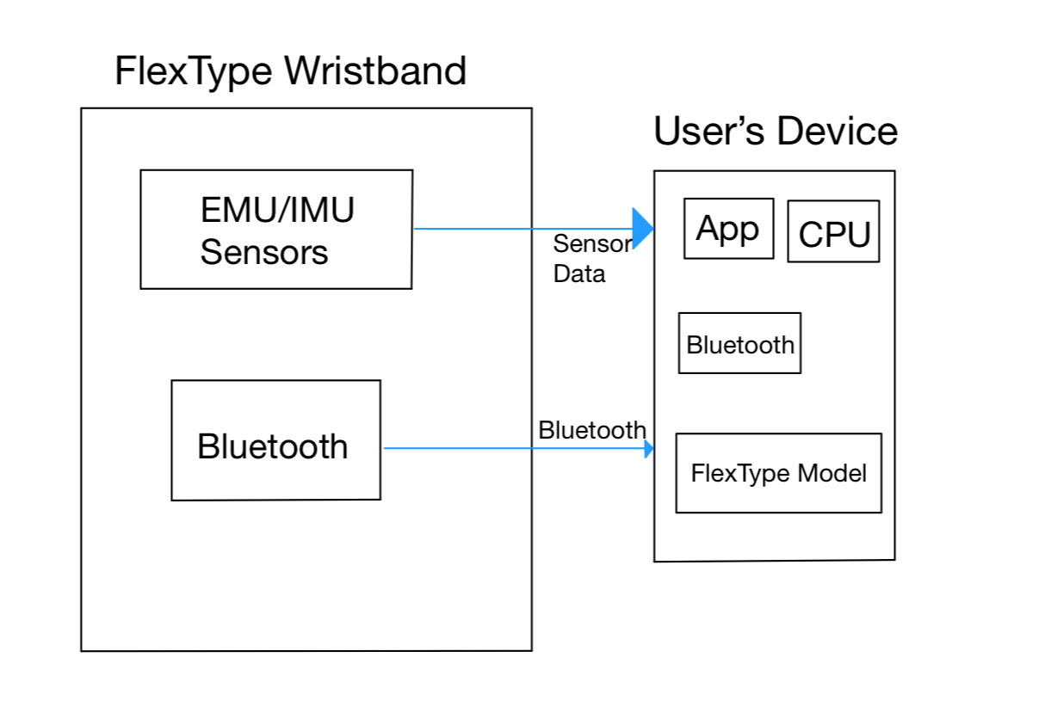
Figure 2. Top Level Block Diagram
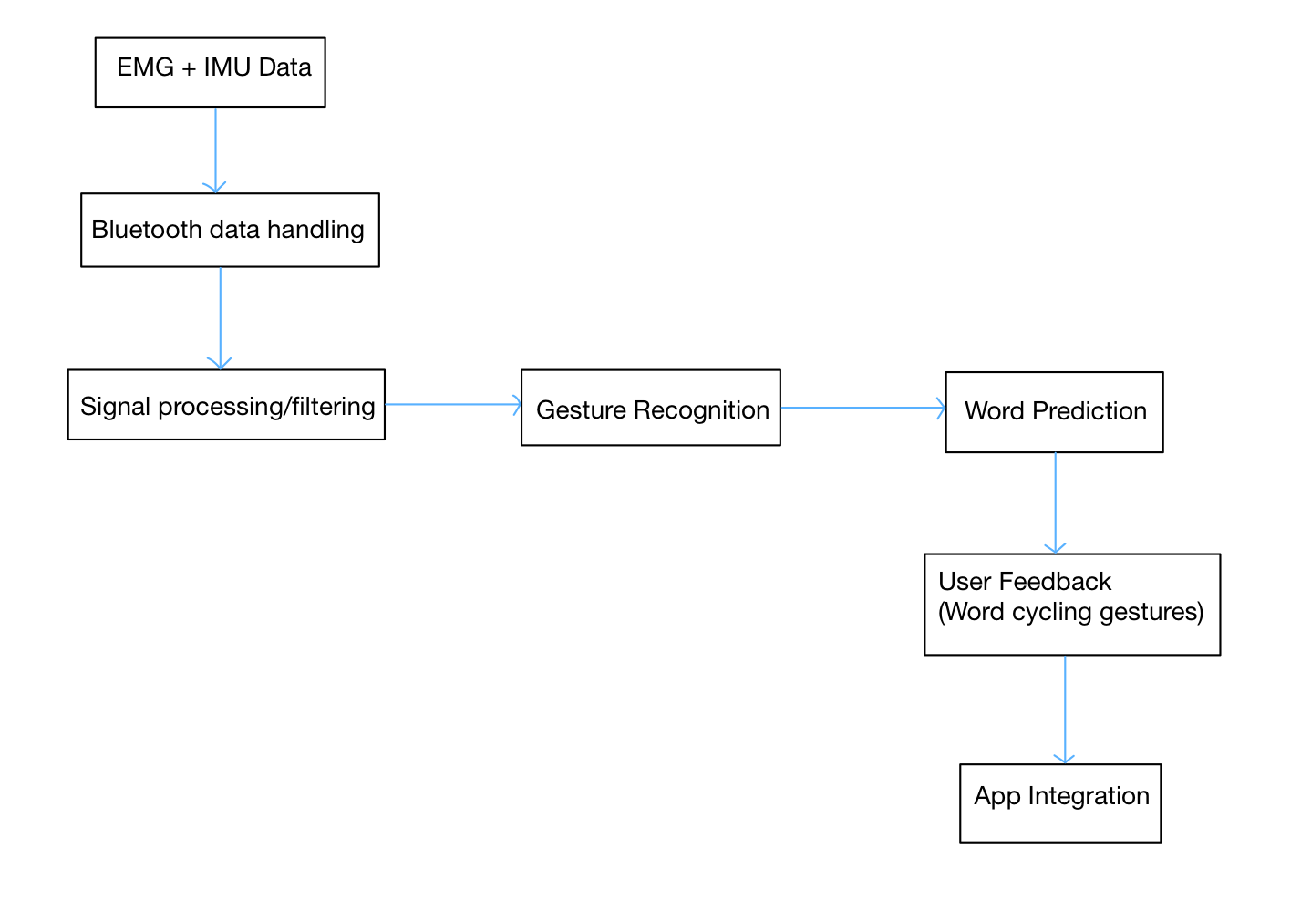
Figure 3. Software System
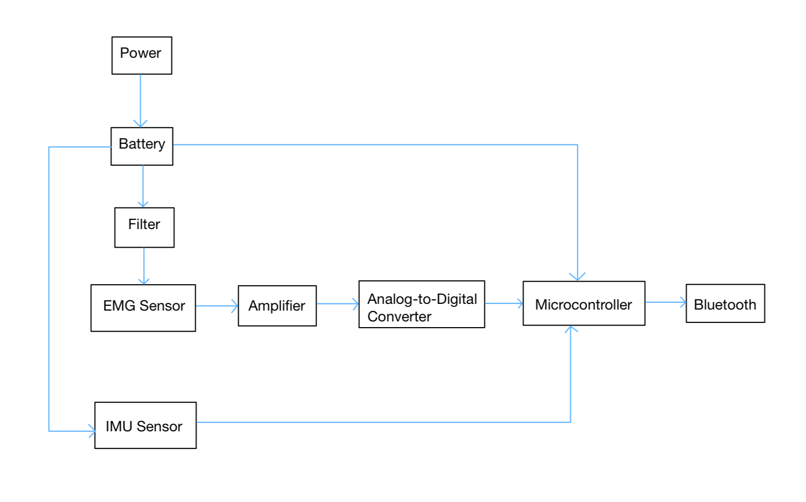
Figure 4. Wristband Subsystem
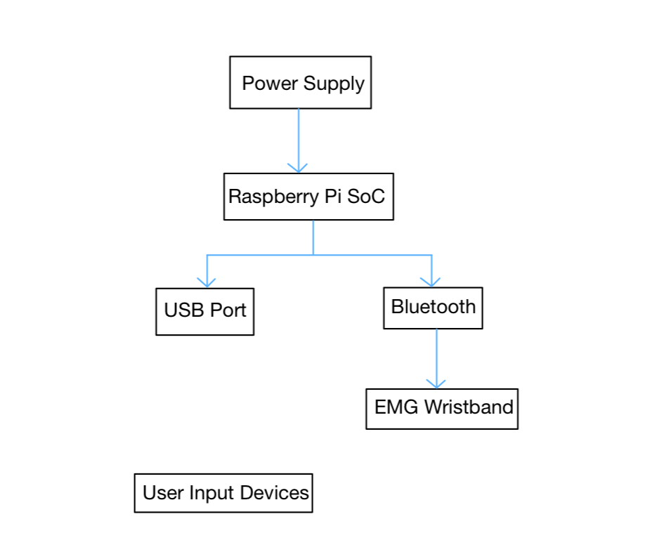
Figure 5. User Device Subsystem
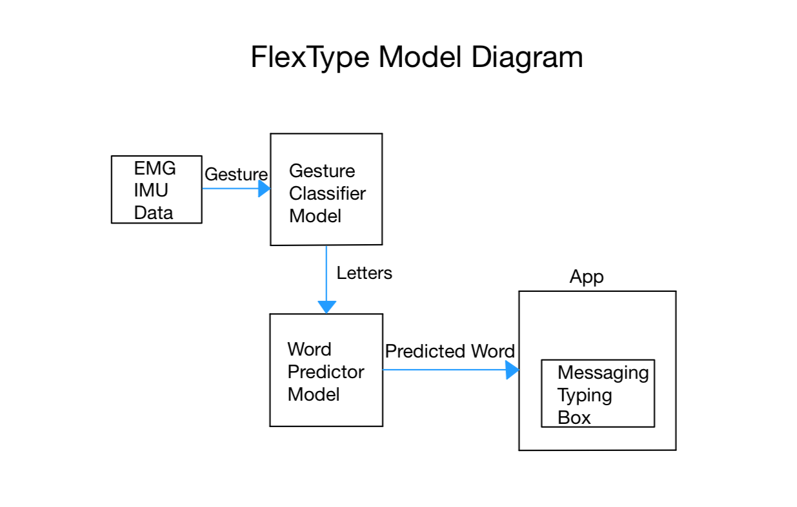
Figure 6. FlexType Model Subsystem

Use Case 1: Sending a Text Message
Description: The EMG wristband and the user device are both paired and charged, ready for typing. The user uses the FlexType EMG Keyboard to type out a text message, then sends it to their friend with their smartphone
Actors: User, EMG wristband, smartphone Bluetooth connection, machine learning algorithm to convert gestures, machine learning algorithm to convert gestures into words, smartphone messaging app
Flow of Events:
- The user puts the EMG wristband on, then connects it to their smartphone via Bluetooth
- The user opens their messaging app and selects who they wish to text
- The user makes a series of gestures that correlate to different sets of letters, which are picked by the EMG on their wrist
- The data from the muscle movements are sent via Bluetooth to the smartphone
- The smartphone passes the data through a machine learning algorithm that converts each muscle movement to the proper set of letters.
- The series of letters is then sent to a second machine learning algorithm that predicts the most likely word the user is trying to type.
- The predicted word is then sent to the text box in the user’s chosen messaging app
- This process repeats until the user is finished typing and sends their message
Alternative/ Exception Flows: If the user makes a mistake when using their gestures, they can delete the mistyped word and re-type it with the correct gestures. Auto-correct on the phone may also be used to correct minor typos. If the incorrect word is predicted, the user will make a gesture that “swipes” to the next most-likely word. They can repeat “swiping” until the correct word is displayed.
Outcome: The user types a complete, correct text message and successfully sends it to their friend.
Swim Lane Diagram:
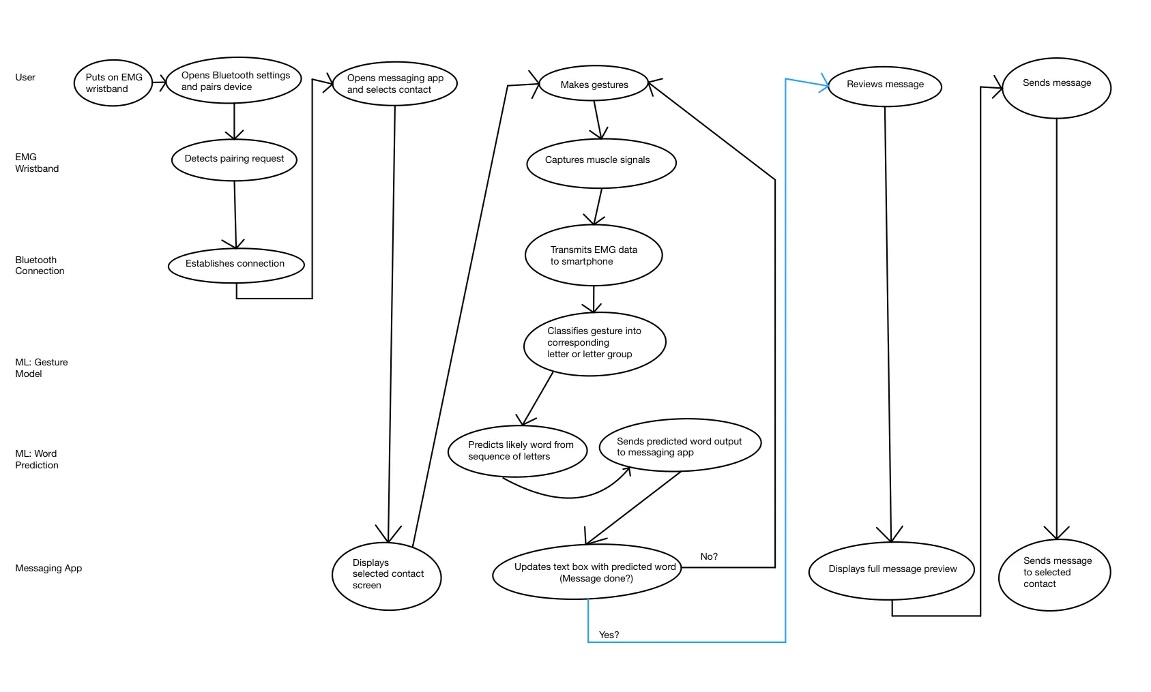
Figure 7. Use Case 1 Swim Lane Diagram

Use Case 2: Starting up the EMG Wristband
Description: The paired EMG wristband and user device are ready to be used. The user will then perform a specific gesture twice in a row within a time frame in order to start up the FlexType EMG Keyboard.
Actors: User, EMG wristband, smartphone Bluetooth connection
Flow of Events:
- The user puts the EMG wristband on their wrist
- Then the user performs a specific gesture. The EMG wristband is in a low-power standby mode; it detects the EMG signal and waits for the user to release the gesture within a specific time frame.
- The EMG wristband detects the release and waits for the user to perform the same gesture within another specific time frame.
- The user performs the gesture again
- The EMG wristband exits its low-power standby mode
- Initializes a Bluetooth connection with the user’s smartphone and starts allowing detection for the other gestures.

Alternative/Exception Flows: If the user has tremors or involuntary movements and accidentally triggers the first specific gesture, the EMG wristband waits for the user to release the gesture. If the user doesn’t release the gesture in time, the device will go back to waiting for the first gesture. If the user also accidentally releases the gesture in time, but does not perform the second gesture in time, it will also go back to waiting for the first gesture.
Outcome: The user successfully starts up the EMG wristband and can begin sending messages.
Swim Lane Diagram:
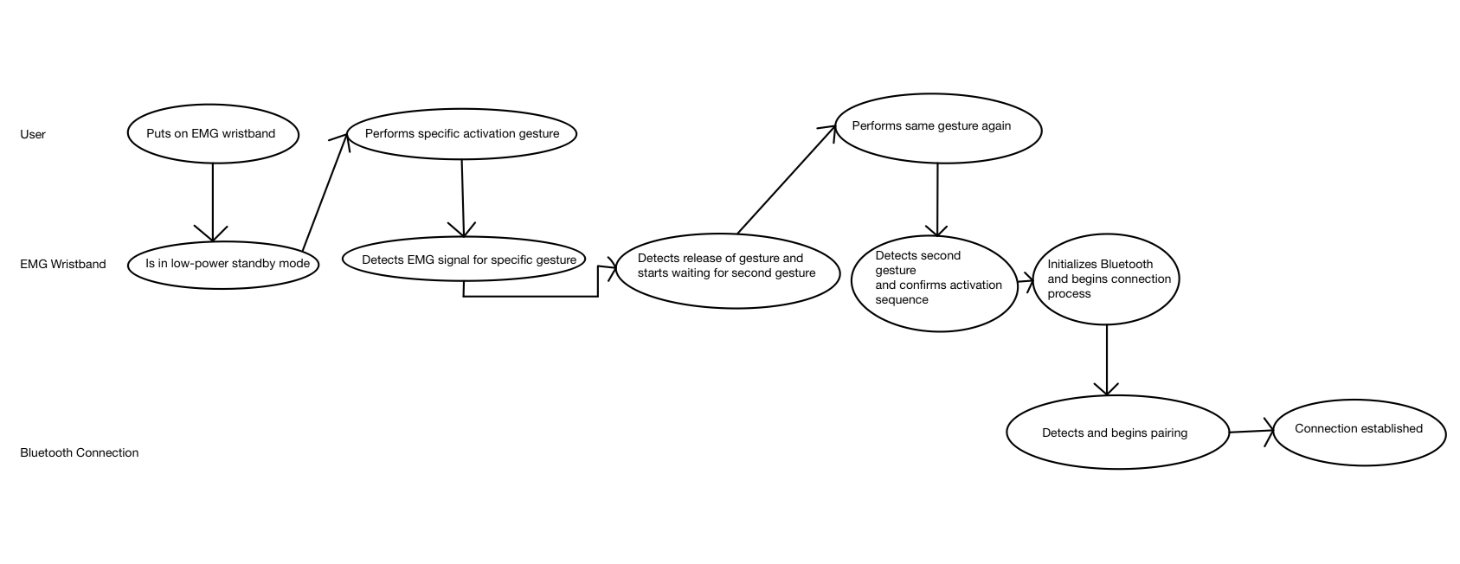
Figure 8. Use Case 2 Swim Lane Diagram

Use Case 3: Gesture Error Correction
Description: The user uses the FlexType to type, and the word prediction model shows a word the user did not want to type. The system allows correction through dedicated gestures, allowing users to “scroll” through predicted word options.
Actors: User, EMG wristband, Bluetooth connection, user device, word prediction & gesture models
Flow of Events:
- The user puts on the EMG wristband
- Connects to their device via a Bluetooth connection
- The user begins typing with gestures
- While typing the model predicted a word the user did not want to say
- The user performs a correction gesture which “scrolls” through a couple of predicted words
- When the correct word is selected the user continues typing
Alternative/Exception Flows: The word prediction model will try and predict any word based off the letters selected that makes sense to the context of the sentence. If the correct word is not predicted, the model will show a list of every possible English word that the combination of letters can create. The user can then select the word they originally wished to type out.
Outcome: The user successfully corrected the word prediction error
Swim Lane Diagram:
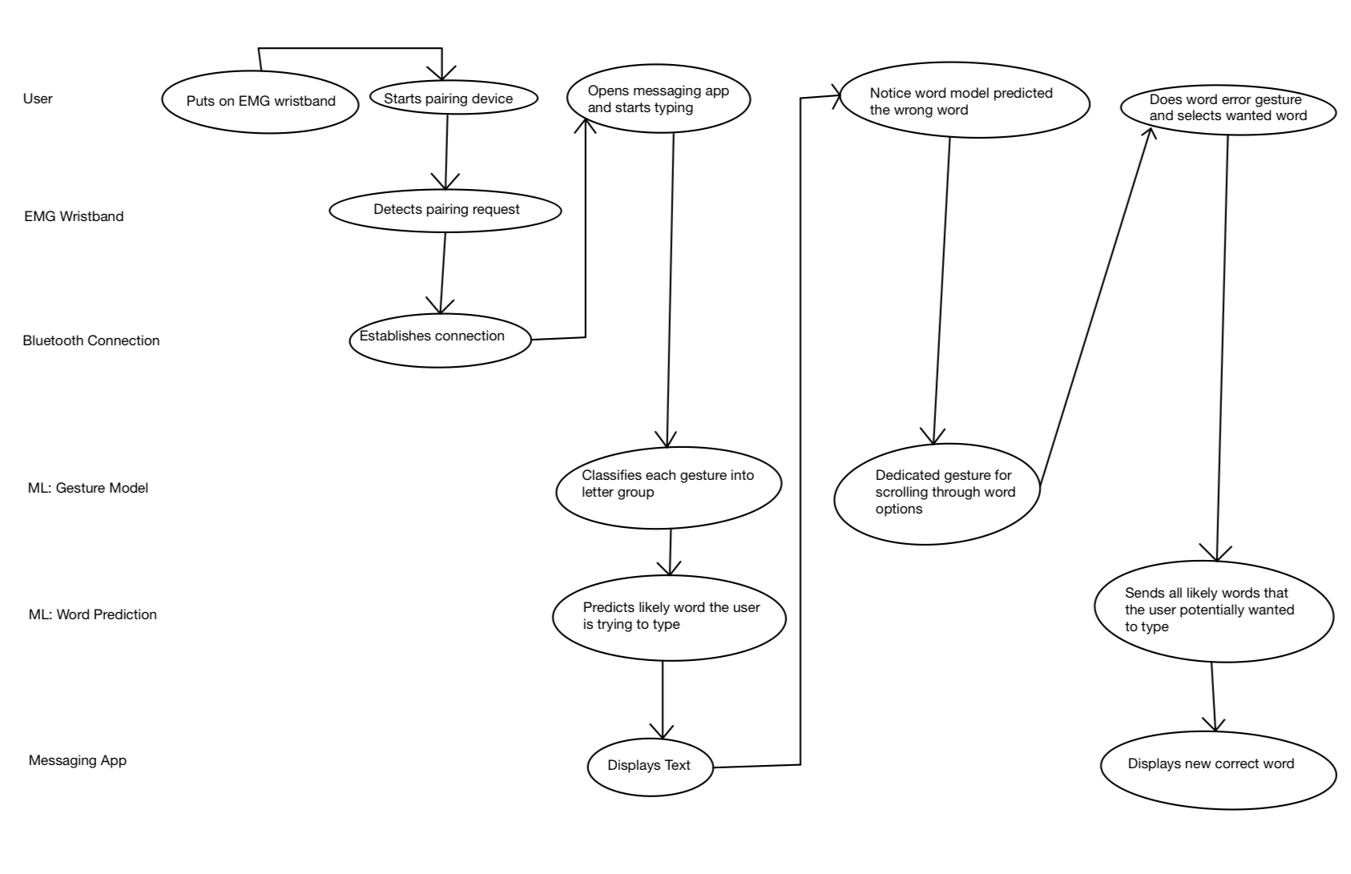
Figure 9. Use Case 3 Swim Lane Diagram

Bill of Materials (BOM) - Key Components & Estimated Costs
Table 2. Bill of Materials
Component | Description | Quantity | Price
Raspberry Pi 4 | Data processing and running or accessing the gesture model and word prediction model locally | 1 | $45
8 Channel EMG Sensor (MyoWave) | Captures muscle activity signals from the user’s forearm and wrist | 1 | $150
IMU Sensor | Captures orientation of arm for EMG reading accuracy | 1 | $15
Wristbands | Housing for EMG sensor and electronics to wrap around user’s arm | 1 | $10-20
Jumper Wires | Connecting sensors, IMU, and Raspberry pi | ~10 | $5
3D printed enclosure | Protects components and to look more like a real product | 1 | $Free.99
Estimated Prototype Total ≈ $235.00 USD

Product Requirements

FlexType Model Sub-System
Description: The overall purpose of this subsystem is to incorporate the word prediction model into the keyboard and to map the gestures that the user has to the neural network model that predicts the word that the user is attempting to type. The importance of this sub-system is its ability to connect the model to the wristband.
Key Components: Key components include:
- Neural network model for word prediction
- Model for gesture recognition
- Device that is connected to the FlexType Keyboard.
Interfaces: This subsystem interacts with the wristband subsystem directly polling and collecting data from the wristband to interpret any gestures made by the user. Also this subsystem interacts with the device of the user by communicating with the device after finding a predicted word via the word prediction model.
Requirements:
1. Shall accurately distinguish and determine gestures made by the user
2. Shall map gestures from the user to certain letters/words/actions
3. Shall return a word/letter/action based on the created gesture from the user

FlexType Wristband Sub-System
Description: The overall purpose of this subsystem is to accurate read the user’s muscle signals based on the gestures made. Then to make sure that there are clean and convertible data generated from the device that can be digitized and used within the models.
Key Components: Key components would include:
- the battery bank
- EMG sensor
- A/D converter
- Amplifier
- The microcontroller.
Interfaces: This subsystem interacts with the model subsystem sending the model subsystem the data from the EMG sensor, accurately recording signals from the user’s muscles which then gets amplified, then converted from Analog to Digital, sent to the microcontroller for signal processing, and then sent for further processes to the model subsystem.
Requirements:
1. Shall accurately record the data from the EMG device.
2. Shall successfully convert the data from analog to digital and allow for data to be usable.
3. Shall comply with any federal power requirements while ensuring reliability and functionality

User Device Sub-System
Description: The overall purpose of this subsystem is to provide connectivity from the user device to the wristband and models, while also serving as a source of additional computation and memory.
Key Components: Key components include:
- Central Processing Unit
- Gesture model
- Word prediction model
- Messaging application/software
Interfaces: This subsystem interacts with both the wristband and the word model subsystems by being the hub of the information that is sent by both of the subsystems. As well as being the device that produces the generated output from the models.
Requirements:
1. Shall display words generated by the prediction model
2. Shall allow the user to navigate the application
3. Shall allow the user to type into desired messaging application
4. Shall efficiently utilize CPU, preserving power
5. Shall allow reliable physical connection to wristband

Relevant Engineering Standards
Table 3. Relevenat Engineering Standards
Standard Name | Category | Purpose / Description | How It Applies to the Project
Bluetooth low Energy | Communication & Networking | Specifies wireless communication for low power and short-range devices | Used for connecting the EMG wristband to the user’s device
RoHS (Restriction of Hazardous Substances Directive) | Power, Safety, Environmental | Restricts the use of hazardous materials | Ensures the device is safe for users
UART | Embedded Systems & Hardware | Serial communication for asynchronous data transfer | Used for communication between the EMG, MCU, and IMU
I²C | Embedded Systems & Hardware | Low-speed short distance communication between chips | Used for interfacing the IMU sensor and MCU
USB | Embedded Systems & Hardware | Data and power delivery over USB connection | Used to power and program the Raspberry Pi and connect it to peripherals

Realistic Constraints and Design Impact
Table 4. Realistic Constraints
Constraint Type | Impact on Design Decision
Economic | To reduce cost, we decided to use two 2-channel EMG sensors for the PCB of our wristband since the 8-channel EMG sensor would be too expensive.
Ergonomic | The device will need to be very lightweight, which will limit the size and weight of the PCB components. This is so that the wristband can be portable and easily worn by the desired customers.
Time/Schedule | To gather EMG data, we currently depend on a teacher assistant to be able to access the EMG sensor in the lab. This means purchasing our own would allow more frequent testing and reduce delays in our project’s progress.
Health and Safety | Since the wristband makes contact with the user’s skin, we will need to use low voltage power to prevent electrical hazards.

Proof-of-Concept (Feasibility) Projects

Main Issues
The main issues that need to be addressed are:
- Whether or not the group will have an allotted EMG device for the team to use exclusively
- Making sure that running the Prediction Model locally can be implemented
- Developing PCB for the EMG device
- Figure out whether to connect the Raspberry Pi to ADC directly or have a Bluetooth connection that will then need an additional microcontroller
Plan to Address Risk and Validate
The plan for each issue respectively is as follows:
1. First ensuring that we have a schedule that not only aligns with the allotted time that we have for the class but also time outside of class that will allow us to have additional time to collect data and grow familiar with the EMG.
2. Over the break and during the first few weeks of the spring semester, try and setup the local prediction model, deploy the code of the model on the raspberry pi then instead of calling to the server, call to the local host. The risk associated with failing to run the model locally, is the sake of simplicity and future implementation and improvements that can be made for the product.
3. Learning how to design PCB over the break will allow us to get ahead on understanding what we may need and allowing us to test in conjunction with the rest of the hardware. The risk of PCB design would be that there will be a fair amount of trial and error, which would hopefully be minimized as much as possible if we were to learn and develop our understanding of PCB design over the break.
4. When we acquire the ADC and have a microcontroller to compare reliability, latency, and implementation with, we can see if wireless connectivity can be feasible. The risk is that there may be some mechanical restrictions when considering connecting the ADC to the Raspberry Pi and how we are going to ensure connectivity while allowing the user to be mobile while using the device.

Plan to Demonstrate
The plan to demonstrate each step is as follows:
- Ensure that there is a fair amount of documentation and data supporting that despite the risk implementation is possible
- Ensure that there are compatibility and connectivity between said resolved issue and the rest of the system
- Documentation of each issue and what was done to resolve each issue

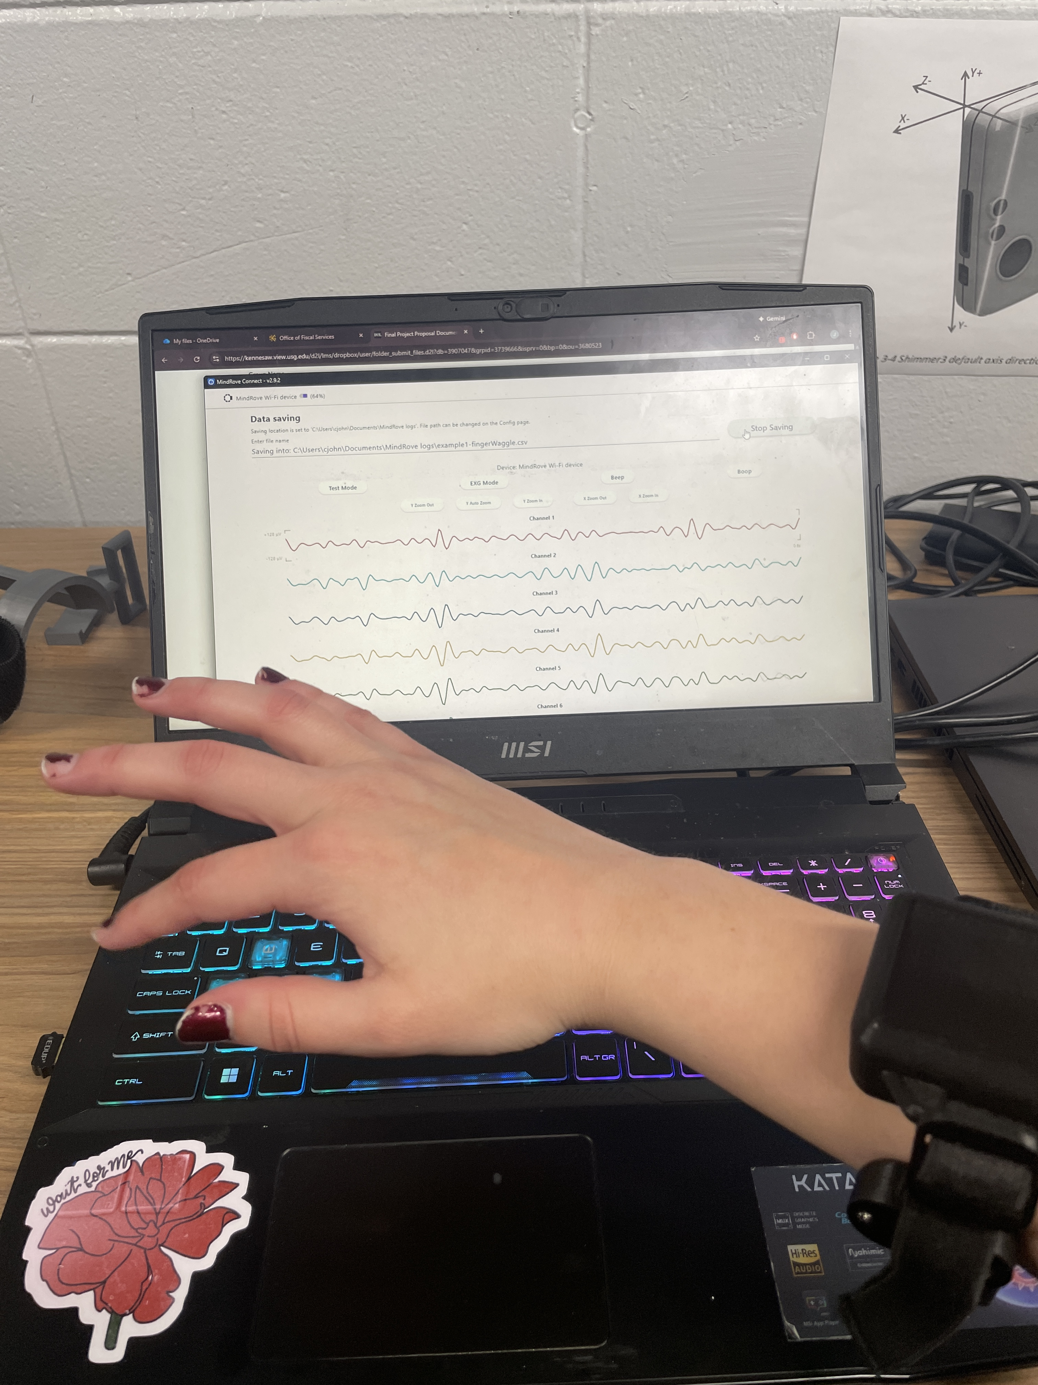
Figure 10. EMG Collecting Data
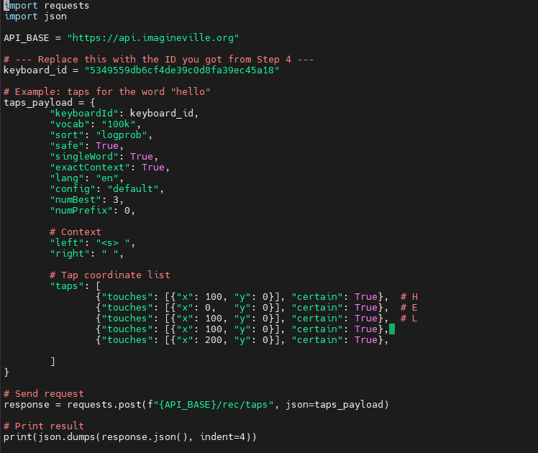
Figure 11. Word Model Predicting "Hello"
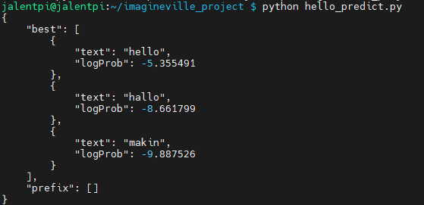
Figure 12. Word Model "Hello" Results
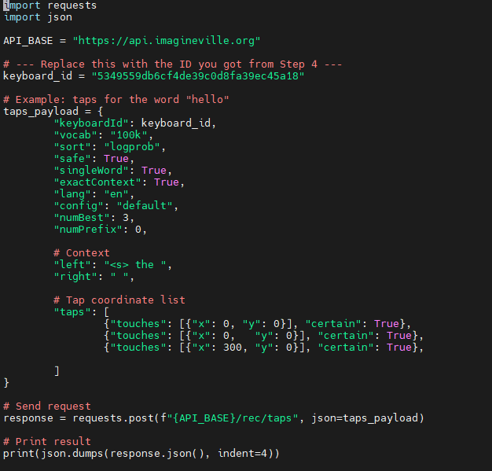
Figure 13. Predicting “Cat" with Left Context "The"
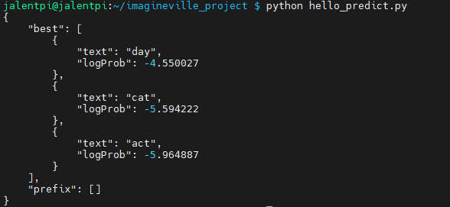
Figure 14. Context Predicting Results

Project Planning

Phase 1
Phase 1 of our project was broken down into the following components. Each team member contributed to the tasks listed below.
Table 5. Phase 1 Plan
Task | Completed On
Customer Interview Plan | October 3, 2025
Concept Proposal Demonstration | October 8, 2025
Concept Proposal Document | October 12, 2025
Product Feature Set and Use Cases | October 21, 2025
System Block Diagrams and Product Requirements | October 28, 2025
Product Requirement Document (Draft) | November 4, 2025
Proof-of-Concept: Risk Assessment | November 8, 2025
Product Requirement Document (Final) | December 14, 2025
Research Step | December 14, 2025 – January 12, 2025

The research step of our plan includes researching how to build a PCB (Jalen and Kejon) and what existing gesture classification methods already exist (Julia and Giancarlos).

Phase 2
Phase 2 of our plan will consist of initial software and hardware creation.
The software development team will consist of Julia Johnson and Giancarlos Hernandez. The hardware development team will consist of Jalen Tottess and Kejon Ivery.
Table 6. Hardware Development Plan
Task | Goal
Create a plan for PCB | Determine which components (resistors, IMU, etc.) are needed for the PCB. Determine how they will connect together.
Build PCB in EDA software | Use EDA platform (such as EAGLE) to design the PCB board.
Order PCB | Order the PCB. Estimate 2-3 weeks for arrival.
3D print/ build casing for PCB | Design the external case that will go around the PCB and connect all hardware components together
Merge PCB with casing | Merge PCB board with wearable case. Make changes if needed.
Test all hardware components are functional | Verify that all components are operational inside of case and while being worn.

Table 7. Software Development Plan
Task | Goal
Load FlexType model on Raspberry Pi | Ensure that FlexType model can function on local Raspberry Pi
Decide 10 initial gestures | Determine 10 potential gestures to represent numbers, space bar, delete, and swipe.
Create plan for gesture classification model | Determine what model(s) will be used and tools that will be used to evaluate them.
Gather gesture data from volunteers | Collect EMG data from volunteers performing each gesture to build custom dataset. Continue this throughout duration of project.
Build useable dataset (~50 samples) | Gather data from at least ~50 individuals.
Determine 8 final gestures | Determine which 8 gesture are most easily predicted by the model.
Build gesture classification model | Build/ implement gesture classification model.

Phase 3
This phase of the plan is focused on combining software and hardware components, then making changes as needed.
Task | Goal
Integrate gesture classification model with FlexType model | Ensure that gesture model can pass in data to FlexType model with ease
Verify accurate data is collected from PCB | Verify that the data received from PCB generally matches data from commercial EMG.
Verify that spontaneous gestures are predicted correctly | Test multiple gestures while program is running. Ensure that gesture is regularly predicted correctly.
Update model to improve performance | Make changes to model to function better with PCB and make more accurate predictions.
Achieve 90% accuracy on spontaneous word prediction | Test multiple words and sentences to ensure functionality. Should achieve ~90% accuracy on predictions.
Order/ receive updated PCB (if needed) | If PCB is not functional or less than ideal, redesign and make changes. Order in time to have 2-3 week delivery.
Create display to show predicted word and typed phrase | Create a display (either display screen or designated window) to show most recent predicted word compared to full sentence/ phrase.

Gantt Chart
The following figure shows our Gantt chart and estimated schedule for each part of this project.
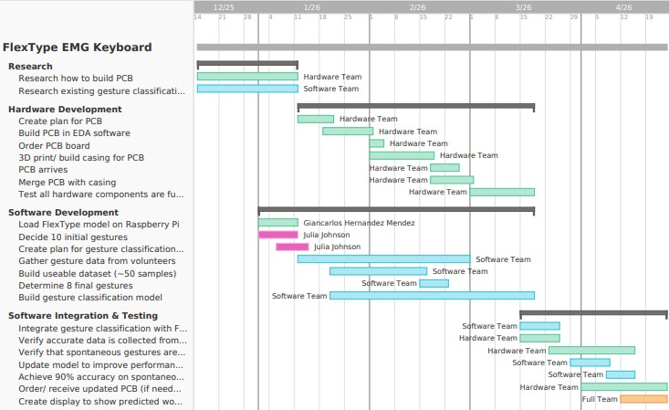
Figure 15. Gantt Chart

Bibliography
- Gaines, D., Baker, M., & Vertanen, K. (2023). FlexType: Flexible Text Input with a Small Set of Input Gestures. International Conference on Intelligent User Interfaces, Proceedings IUI, 584-594. http://doi.org/10.1145/3581641.3584077
Retrieved from: https://digitalcommons.mtu.edu/michigantech-p/16980

